Database dokumentasjon

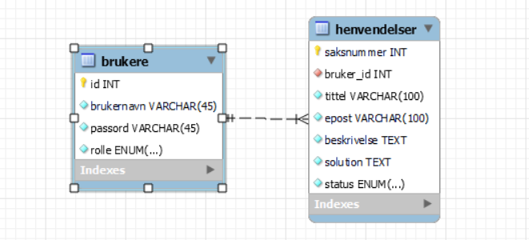

Database schema  
  
-- MySQL Workbench Forward Engineering

SET @OLD_UNIQUE_CHECKS=@@UNIQUE_CHECKS, UNIQUE_CHECKS=0;

SET @OLD_FOREIGN_KEY_CHECKS=@@FOREIGN_KEY_CHECKS, FOREIGN_KEY_CHECKS=0;

SET @OLD_SQL_MODE=@@SQL_MODE, SQL_MODE='ONLY_FULL_GROUP_BY,STRICT_TRANS_TABLES,NO_ZERO_IN_DATE,NO_ZERO_DATE,ERROR_FOR_DIVISION_BY_ZERO,NO_ENGINE_SUBSTITUTION';

-- -----------------------------------------------------

-- Schema ticket_oppdrag_uke12

-- -----------------------------------------------------

-- -----------------------------------------------------

-- Schema ticket_oppdrag_uke12

-- -----------------------------------------------------

CREATE SCHEMA IF NOT EXISTS `ticket_oppdrag_uke12` DEFAULT CHARACTER SET utf8 ;

USE `ticket_oppdrag_uke12` ;

-- -----------------------------------------------------

-- Table `ticket_oppdrag_uke12`.`brukere`

-- -----------------------------------------------------

CREATE TABLE IF NOT EXISTS `ticket_oppdrag_uke12`.`brukere` (

`id` INT NOT NULL AUTO_INCREMENT,

`brukernavn` VARCHAR(45) NOT NULL,

`passord` VARCHAR(45) NOT NULL,

`rolle` ENUM('Administrator', 'Begrenset tillgang') NOT NULL,

PRIMARY KEY (`id`))

ENGINE = InnoDB;

-- -----------------------------------------------------

-- Table `ticket_oppdrag_uke12`.`henvendelser`

-- -----------------------------------------------------

CREATE TABLE IF NOT EXISTS `ticket_oppdrag_uke12`.`henvendelser` (

`saksnummer` INT NOT NULL AUTO_INCREMENT,

`bruker_id` INT NOT NULL,

`tittel` VARCHAR(100) NOT NULL,

`epost` VARCHAR(100) NOT NULL,

`beskrivelse` TEXT NOT NULL,

`solution` TEXT NOT NULL,

`status` ENUM('Åpen', 'løst') NOT NULL,

PRIMARY KEY (`saksnummer`),

INDEX `fk_henvendelser_brukere_idx` (`bruker_id` ASC),

CONSTRAINT `fk_henvendelser_brukere`

FOREIGN KEY (`bruker_id`)

REFERENCES `ticket_oppdrag_uke12`.`brukere` (`id`)

ON DELETE NO ACTION

ON UPDATE NO ACTION)

ENGINE = InnoDB;

SET SQL_MODE=@OLD_SQL_MODE;

SET FOREIGN_KEY_CHECKS=@OLD_FOREIGN_KEY_CHECKS;

SET UNIQUE_CHECKS=@OLD_UNIQUE_CHECKS;